**Foredragsholdere NFSU konferanse 2024:**

**Prekonferanse**

*Dr Amanda Jones*

Dr Amanda Jones is a consultant perinatal psychotherapist.  She works in a  a community perinatal service in the UK that offers psychiatric and psychotherapy treatment to pregnant women and their partners experiencing serious mental illness during pregnancy and up until the baby reaches toddlerhood. The psychotherapy treatment usually includes the baby.  Amanda’s doctoral research at the Tavistock Centre/UEL studied how mothers' use of maladaptive defensive processes can derail their baby's development. Amanda speaks nationally and internationally on the subject.

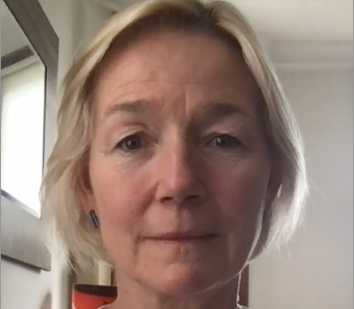

Morning TITLE:

Parental denial of their baby’s primary emotions:  some thoughts about the consequences for a baby’s forming body and mind

ABSTRACT:

This presentation considers the baby’s emotional experience when a parent unconsciously denies their baby’s primary emotions.  Repeated early parental rejection of the baby’s developing mind and body will have many consequences.  Some thoughts about how parental denial can impact a baby’s forming sense of self-hood, personality and unconscious self-protective processes (defences) will be considered.

Afternoon TITLE:  Understanding and working with concerns about a parent’s capacity to be ‘good enough'

For any professional practitioner, developing an opinion on what constitutes ‘good enough’ parental care is a complicated task.  It involves getting to know a parent’s history and trying to understand a parent’s conscious and unconscious conflicting feelings about their baby.  It also involves thinking about the different social circumstances that may be creating intolerable stress for a parent. The lecture will describe a model to help clinicians systematically think about what’s important from a baby’s point of view and a way of sharing concerns with a parent and proactively addressing concerns.  The model can help practitioners work with the inevitable worry when risk and safeguarding concerns are evident.

**Dag 1**

*Tessa Baradon*

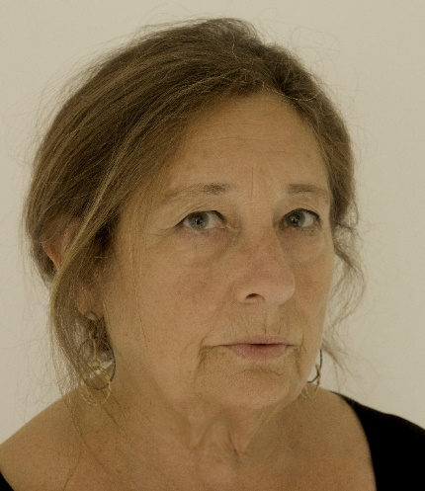

Title: RUPTURE AND REPAIR IN IMH PRACTITIONER-CLIENT/S RELATIONSHIPS

Summary of presentation (Abstract):

Pioneers of infant research such as Stern, Trevarthen, Tronick and Beebe have contributed to understanding how the parent and infant co-construct their relationship in micro-events of interaction. Such interactions, largely embodied and too fleeting to reach conscious reflection, move in an ordinary way between states of ‘matching’, ‘mismatching’ and ‘repair’ between the partners (Tronick, [2007](https://onlinelibrary.wiley.com/doi/10.1002/imhj.22073#imhj22073-bib-0063); Cohn & Tronick, [1989](https://onlinelibrary.wiley.com/doi/10.1002/imhj.22073#imhj22073-bib-0024)).

Some mismatches, however, create a rupture which has the potential of negatively influencing the course of the relationship. In this talk, I will focus on such ruptures, which occur – inevitably – in infant mental health practice as in other situations of human relationships. I draw upon research into clinical process in psychoanalytic parent-infant psychotherapy (PPIP), in which we examined the characteristics of ruptures and their repair at the micro-level of the here-and-now in therapy sessions. Video material will be shown to illustrate how the very processes that create the rupture also frame interactive repair. I will argue that while the research base was therapy, the findings are relevant to all practitioners working with infants and their parents.

*Heidi Fjeldheim*, PhD candidate, Specialist in infant and Adolescent mental health

Heidi Fjeldheim currently holds a position as Special Advisor at The Regional Center for Child and Adolescent Mental Health East and South (RBUP), where she holds lectures in various fields within perinatal and infant mental health for students undergoing clinical specialisations. She also holds a PhD position at Ahus, Norway, where she is part of the study: “To repeat or not to repeat – how can we prevent intergenerational transmission of adverse childhood experiences?”.

Her clinical expertise is in perinatal and infant mental health, with special interest in psychotherapy for families with intergenerational adversities.

Title:

When you open the door to the past anything can happen – A qualitative study of angel memories with pregnant women with high ACEs.

In her talk, Heidi will present preliminary findings from a qualitative study on the use of the Angels in the nursery Interview with pregnant women with multiple childhood adversities, such as violence, abuse, traumas, and neglect. The intention of retrieving and integrating angel memories is to find moments of feeling loved, secure, and safe that can nuance the dominating narrative. Through exploring pregnant women`s experiences with the interview we aim at getting a better understanding of the variation of angel memories and ways of narrating, as well as their reactions during and after the interview and their needs, so we can tailor the use of angel memories in treatment.

**Dag 2**

*Tine Gammelgaard Aaserud*

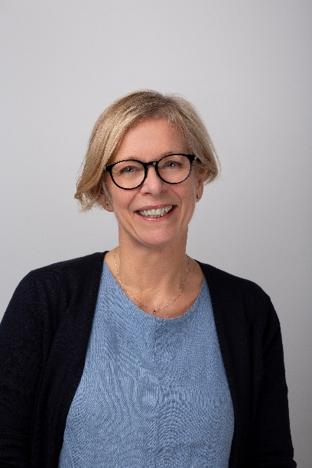

Tine Gammelgaard Aaserud er Nasjonal fagsjef for utprøving av programmet Sammen på vei som er den norske utgaven av Nurse-Family Partnership (NFP). Hun er ansatt ved Regionsenter for barn og unges psykiske helse, Helseregion Øst og Sør (RBUP). Tine har bakgrunn som jordmor og har blant annet mange års erfaring fra arbeid i kommunen med svangerskapsomsorg, hjemmebesøk i barseltid og oppfølgning av gravide ansatte i kommunen. Hun har master i helse og empowerment. Hun har jobbet med Sammen på vei siden oppstart i 2015.

*Emma Broberg*

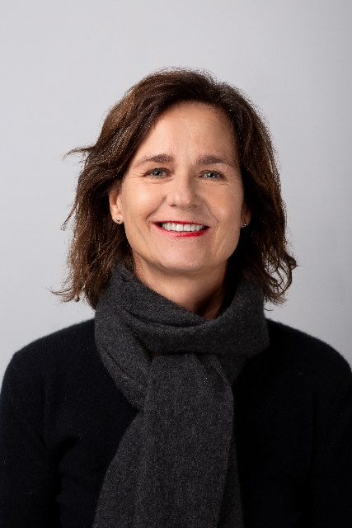

Emma Broberg er spesialrådgiver på Nasjonalt kontor i Sammen på vei – Nurse-Family Partnership (NFP). Hun er ansatt ved Regionsenter for barn og unges psykiske hele, Helseregion Øst og Sør (RBUP). Emma har bakgrunn og erfaring som helsesykepleier og familieterapeut. Hun har jobbet i Oslo kommune siden 2001 og blant annet bidratt med etablering av Familiesentermodellen i bydel Søndre Nordstrand. Hun har jobbet med Sammen på vei/NFP siden oppstart i 2016. Først som teamleder for teamet i Oslo, før hun begynte på Nasjonalt kontor 2021.

**Tittel: Å arbeide styrkebasert med førstegangs foreldre med sammensatte utfordringer: Erfaringer fra utprøvingen av Sammen på vei - et kunnskapsbasert oppfølgingsprogram.**

Kort intro:

Sammen på vei er et frivillig oppfølgingsprogram for kvinner med sammensatte utfordringer som skal bli mor for første gang. Deltakerne i programmet følges opp av spesialopplærte helsesykepleiere og jordmødre fra tidlig i graviditet og frem til barnet fyller to år. Oppfølgningen er omtrent hver andre uke og ved hjemmebesøk. Overordnet mål med programmet er å fremme barnet og morens helse i svangerskapet, fremme barnets helse og utvikling og fremme foreldres helse og fremtidige livssituasjon. Sammen på vei er kunnskapsbasert og det er prinsipper for programmet at man jobber styrkebasert og med endringsfokus. Programmet har vært under utprøving i Norge siden 2016 og det er opparbeidet erfaringer med å jobbe styrkebasert med familier med sammensatte utfordringer.

*Emma Maria Bärs, psykolog*

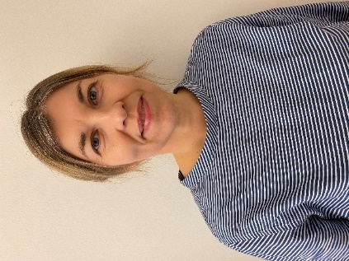

Emma Maria Bärs er uddannet psykolog, og har bl.a. over 10 års klinisk erfaring fra Ambulatorium for spæd- og småbørn i Region Hovedstaden i Danmark hvor børn fra 0-3 år er udredt og behandlet. En af opgaverne har været at give forebyggende behandling til gravide og spædbørnsforældre med psykisk sårbarhed. Emma har siden 2022 været ansat i Børne- og ungdomspsykiatriens Forskningsenhed. Hun er særlig optaget af at udvikle og styrke den forebyggende hjælp og støtte til psykisk sårbare forældre og deres små børn.

Hun er aktuelt ansat som forsker i interventionsstudiet Via Family 2.0, med et særligt fokus på psykisk sårbare forældre og deres børn 0-3 år.

Titel på præsentationen:

VIPP-SD som forebyggende intervention med spæd- og småbørnsforældre i psykiatrisk behandling i Danmark – et feasibilitystudie

Kort præsentation af temaet:

I forskningsprojektet jeg vil redegøre for, har vi ønsket at undersøge hvorvidt VIPP-SD-metoden (Video-feedback Intervention to Promote Positive Parenting and Sensitive Discipline) er egnet som forebyggende og støttende intervention i en dansk kontekst med psykisk sårbare spæd- og småbørnsforældre. VIPP-SD er ikke tidligere undersøgt i en dansk kontekst med spæd- og småbørnsforældre i aktuel psykiatrisk behandling.

*Bibbi Lindahl*, leg psychologist, leg psychotherapist, specialized in psychotherapy for children and

youth.

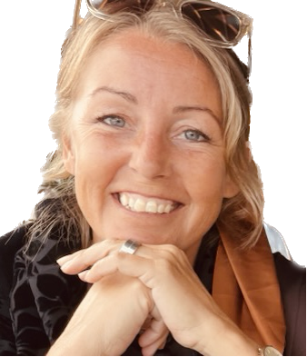

Bibbi Lindahl leg psychologist, leg psychotherapist, specialized in psychotherapy for children and youth.

Bibbi Lindahl holds a position as Specialist psychologist at The Regional Reception for Child and Adolescent Mental Health (BUP), where she works with a number of treatment methods, among those are CPP, DBT, TF-CBT, Affect-focused short-term therapy, IPT-A, dynamic child therapy, EMDR and structural dissociation based on S. Boon. She currently works both in a toddler team with CPP and child therapy and in a DBT team and is part of a county-wide development group for BUP in Västernorrland. In 2014, together with her colleague Sofia Rocksén, she developed a transdiagnostic parent group treatment, *Perspektiv*. The aim was to help parents of children with severe dysregulation problems to gain more tools to understand the child's behavior and manage both their own and the child's emotional reactions, as well as strengthen parental mentalization and attachment. *Perspektiv* has a theoretical starting point in interpersonal neurobiology and is primarily grounded in the methods DBT and Theraplay, more can be found at [www.perspektivonline.com](http://www.perspektivonline.com).

She also drives a private psychotherapy clinic for both children and adults who can´t get help in other health care facilities.

In her talk, Bibbi will both present preliminary findings from two qualitative studies on *Perspektiv* in addition to describing it´s content and the therapeutic stance in this group treatment.

*Kjersti Sandnes,* PhD, clinical psychologist

Kjersti Sandnes currently holds a position as associate professor at The regional center for child and youth mental health and child welfare (RKBU Mid-Norway) at NTNU, where she coordinates the infant mental health- team and teaches a variety of topics relevant for the field. She has many years of experience from working with infant mental health in Trondheim commune. In her doctoral research, she studied mothers’ representations, or internal working models, of their children. Using data from an RCT-study conducted in naturalistic community settings, she investigated the psychometric properties of an instrument that measures parents’ representation, the Working Model of the Child Interview (WMCI). Also, she studied whether a Marte Meo-based video-feedback interaction intervention (VIPI) altered maternal representations differently than treatment as usual at local Well Baby Centers, and whether altered maternal representations were related to altered mother-infant interaction quality.

Title:

Parents’ caregiving representations: Theoretical perspectives and clinical implications

In her talk, Kjersti will present theoretical perspectives of parental caregiving representations as well as clinical implications, including some of the results from her studies.