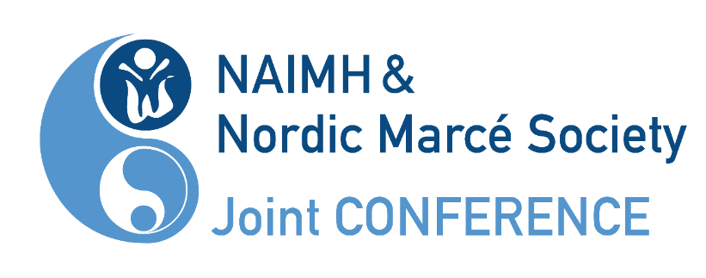
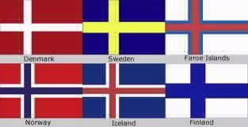
Perinatal & Infant Mental Health
in the Nordic Countries:
Challenges and the Way Forward

1st Nordic Marcé-NFSU Joint Conference

25-27 October 2023

Uppsala University Main Building
Uppsala, Sweden

Preliminary program – changes may occur in the program

Wednesday 25th October 2023 (NFSU)
08:30-10:00 | Registration & Coffee  Entrance hall
10:00-10:10 | Welcome!  Room X |  | Sanne Holst,  President NFSU
Part 1: Parent-Infant Psychotherapy with Traumatized families
Room X

10:10-10:50 | Parent-Infant Psychotherapy with Traumatized Families (English) |  | Dr. Amanda Jones
10:50-11:00 | Short break
11:00-11:45 | Parent-Infant Psychotherapy with Traumatized Families cont. |  | Dr. Amanda Jones
11:45-12:45 | Lunch
Part 2:
Parental stressors & Child’s First Year of Life
Room X

12:45-13:30 | “It came out much better than I feared” - “I felt that being a mother was two, or even four, sizes too big for me.” Experiences and thoughts about mothering and the infant in first year postpartum with bipolar disorder (Norwegian) |  | Teija Anke  psychologist, PhD Vestre Viken, Rbup Øst og Sør
13:30-13:45 | Short Break
13:45-14:30 | Repetitive negative thoughts in the perinatal period – how parents' mental health and attachment to the child are connected (Norwegian) |  | Agnes Bohne, psychologist, PhD, Universitetssykehuset Nord-Norge, Tromsö
14:30-15:00 | Coffee Break
Part 3:
How to Help Parents Look for & Interpret Infants’ Signals & Communication
Room X

15:00-15:30 | NBO & AMOR  Interventions & Sensitivity Training (Norwegian) |  | Unni Tranaas Vannebo, health nurse, NBO master trainer, Seksjon sped- og småbarn, RBUP Øst og Sør.
15:30-16:00 | Implementation of the ADBB in Primary Care in Denmark – Lessons learned and future perspectives. |  | Mette Væver, prof. clinical child psychology, University of Copenhagen
16:00-17:00 | NFSU Annual Meeting for Members  Room X
Thursday, October 26th 2023 (common day)
08:00-09:00 | Registration & Coffee  Entrance Hall
09:00-09:15 | Welcome!  Room X |  | Sanne Holst (President NFSU) & Alkistis Skalkidou (President Nordic Marcé)
09.15-10:45 | Moving on from the First 1000 days in the Nordic countries |  | Moderator:  Birgitta Wickberg  Presenters:  Kari Slinning (Norway)  Liv Lyngå von Folsach (Denmark)  Ann-Cristine Jonsson (Sweden)  Petra Kouvonen (Finland)  Jenny Ingudottir (Iceland) (via zoom)
10:45-11-15 | Coffee Break & poster session:  Mona Bryggman: Solihull-modellen  Kenneth Stensen: Student-teacher relationship scale short form  Stina Helmstrand: Tverrprofessionell mødra- och barnhælsovård
11:15-13:00 | When Regular Outpatient Treatments are not Enough |  | Moderator: Christine Esbensen
 | ”Orkdalsmetoden – The Orkdal Method – Inpatient care for women with postpartum depression” (Norwegian) |  | Elin Killi Olsen, Specialist in psychology, Psychologist, Nidelv DPS, Orkdal døgn, St.Olavs Hospital, Trondheim, Norge
 | Vibygaard (Parent-Child Centre in Denmark) |  | Trine Jensen, Psychologist  Finn Glad, manager and psychotherapist
 | Tvang og omsorg i møte med rusavhengige gravide ved Blå Kors klinikk i Skien, Norge. (Norwegian) |  | Kristin Håland,  Seksjonsleder Blå Kors klinikken Skien
 | Haga Mödra-barnhälsovårdsteam, Gothenburg: Intensive follow-up during and after pregnancy (Swedish) |  | Marina Liljeros, district nurse.  Charlotte Karlsson, health care curator.
13:00-14:00 | Lunch
14:00-16:00 | Parallel Symposiums
 | Room X (Nordic Marcé)  Biological markers (14:00-14:45)  Speaker 1: Mary Kimmel  Speaker 2: Richelle Björvang  Speaker 3: Maria Vrettou  --Short break with poster session--  FOC (15:00-16:00)  Speaker 1: Elisabet Rondung  Speaker 2: Elin Ternström  Speaker 3: Jennie Lenntorp  Speaker 4: Carita Nordin-Remberger | Room IX (NFSU)  Prevention & treatment (14:00-14:45)  Silja B. Kårstad: Early In: A program promoting screening and communication about parental mental health, alcohol use and domestic violence (English)  Åse Bjørseth: Lessons learned from providing Parent-Child Interaction Therapy for Toddlers (PCIT-T) in a Child and Adolescent Mental Health Clinic  (English)  Hedvig Svendsrud: Becoming Dad: Expectant Fathers Attachment Style and Prenatal Representations of the Unborn Child (English)  --Short break with poster session--  Assessment (15:00-16:00)  Stina Helmstrand & Ulrika Hagekull: Tvärprofessionell mödra- och barnhälsovård för sköra och utsatta barn (English)  Karin Colliander: Parent-infant interaction observation scale in a Swedish context  Kjersti Sandnes, Catarina Furmark & Katrine Røhder: Using the Working Model of the Child Interview in the Nordic countries (English)  Nina Sanner & Catarina Furmark: DC:0-5 som processverktyg vid bedömning av späd- och småbarns psykiska hälsa i Norden
16:00-17:00 | Marcé Board Meeting for Members  Room X
19:00 | Conference Dinner
Friday, October 27th 2023 (Nordic Marcé)
09:00-09:15 | Summary of day 1 and 2.  Welcome to day 3.  Room X |  | Prof. Alkistis Skalkidou (President, Nordic Marcé)
09:15-10:15 | Severe mental disorders in the perinatal period  Room X  Introduction: Prof. Louise Howard (zoom)  Speaker 1: Charli Colegate  Speaker 2: Adrianna P. Kępińska  Speaker 3: Yihui Yang  Speaker 4: Felix Wittström |  | Prof. Louise Howard (UK) (via zoom), and participants’ abstracts
10:15-10:35 | Coffee break
10:35-11:35 | Care pathways with focus on stepped care I Room X  Introduction 1: Prof. Nicole Highet  Introduction 2: Prof. Heather O’Mahen  Speaker 1: Sigridur Sia Jonsdottir  Speaker 2: Charles Musters  Speaker 3: Ilaria Lega |  | Prof. Heather O’Mahen (UK) and Prof. Nicole Highet (Australia) (via zoom) and participants’ abstracts
11:40-12:00 | Inspirational lecture:  “Overlooking cultural issues in a multi-cultural, multireligious society” (English)  Room X |  | Prof. John L. Cox (UK)
12:00-13:00 | Lunch
13:00-14:00 | Prediction of peripartum depression  Room X  Introduction: Prof. Trine Munk-Olsen  Speaker 1: Allison Eriksson  Speaker 2: Martina Caglioni  Speaker 3: Michaela Schiøtz  Speaker 4: Ella Schleimann-Jensen |  | Prof. Trine Munk-Olsen (Denmark), and participants’ abstracts
14:00-14:40 | Perinatal mental health in the Nordics:  short history of the Nordic Marcé Society and current regional projects  Room X  Introduction: Ass. Prof. Birgitta Wickberg  Speaker 1: Malin Eberhard-Gran  Speaker 2: Emma Fransson  Speaker 3: Marie Bendix  Speaker 4: Lotte Broberg |  | Ass. Prof. Birgitta Wickberg and participants’ abstracts
14:40-15:00 | Coffee break
15:00-16:00 | Transgenerational effects of peripartum depression  Room X  Introduction 1: Prof. Hasse Karlsson  Introduction 2: Ass. Prof. Carolyn Cesta  Speaker 1: Tiina Riekki  Speaker 2: Angela Lupattelli  Speaker 3: Alina Rodriguez |  | Prof. Hasse Karlsson (Finland), Ass.Prof. Carolyn Cesta (Sweden), and participants’ abstracts
16:00-16:15 | Closing comments and greetings from the president of the international Marcé Society |  | Alkistis Skalkidou, Sanne Holst, Jennifer Payne  (via zoom)

